INSTRUCTOR GUIDE

TOPIC: ENGINE COMPANY OPERATIONS: THE 2 ½ INCH HANDLINE

TIME REQUIRED: 1.5 - 2 HOURS

MATERIALS: Minimum 150 feet 2 ½ inch handline
Smooth bore nozzle, preferably 1 1/8 inch
Engine

=================================================================

MOTIVATION: Use of the 2 ½ inch handline seems to have been abandoned in recent history; this may be the result of staffing cuts or the lack of appropriate training. In either case, this is an extremely effective tool that should not be ignored. All of the techniques demonstrated in this drill can be performed with an engine company that is minimally staffed (i.e. three personnel).

OBJECTIVE (SPO): Given information from lecture and demonstration the student will be able to recognize situations where it is appropriate to utilize a 2 ½ inch attack line and demonstrate the different methods for the deployment and use of this line to the satisfaction of the instructor.

OVERVIEW:
- Situations where the 2 ½ inch line is needed
- Techniques for use of the 2 ½ inch line

ENGINE COMPANY OPERATIONS: THE 2 ½ INCH HANDLINE
Enabling Objectives:
EO-1 Identify the situations when use of the 2 ½ inch attack line is appropriate.

EO-2 Demonstrate three techniques for the deployment of the 2 ½ inch attack line.

- Situations where a large line is
needed:
Utilize the acronym ADULTS
A – Advanced fire on arrival
D – Defensive
U – Undetermined location/extent of the fire
L – Large/uncompartmented areas
T – Tons of water needed
S – Standpipe Operations

- Demonstrate the following techniques:
  - Single firefighter/hose pinned with
knee:

The rear leg must be perpendicular to
the handline, so that the knee stays in
position and doesn’t roll off. The nozzle
reaction is driven into the ground.

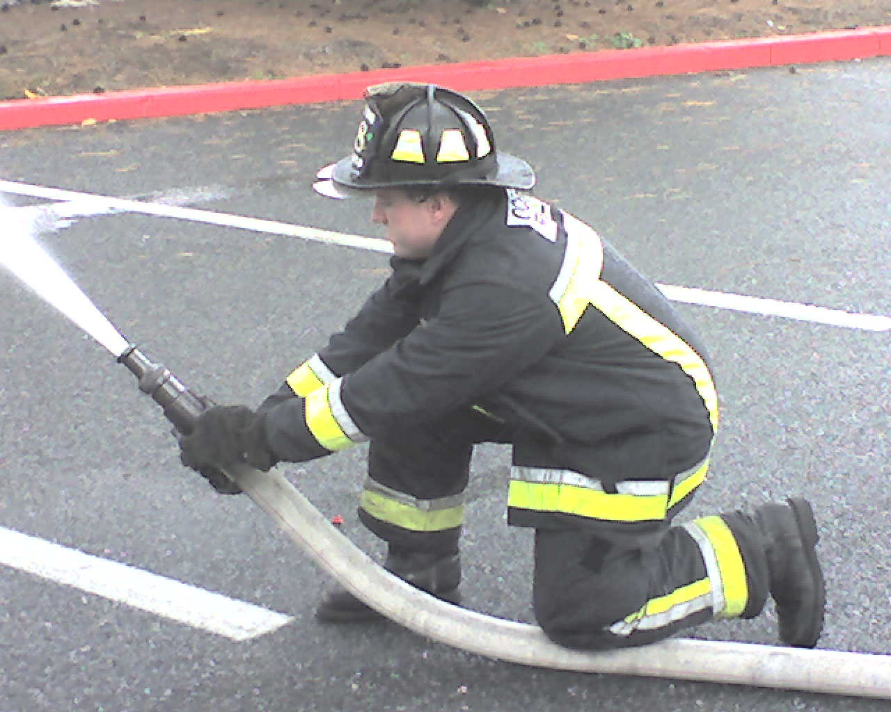

  - Single firefighter/hose locked between
arm and leg:

The line should be locked between the upper
arm and the torso (up in the armpit) and the
right arm should be locked against the inside of
the thigh. Notice the back leg is up and the
front leg is down.

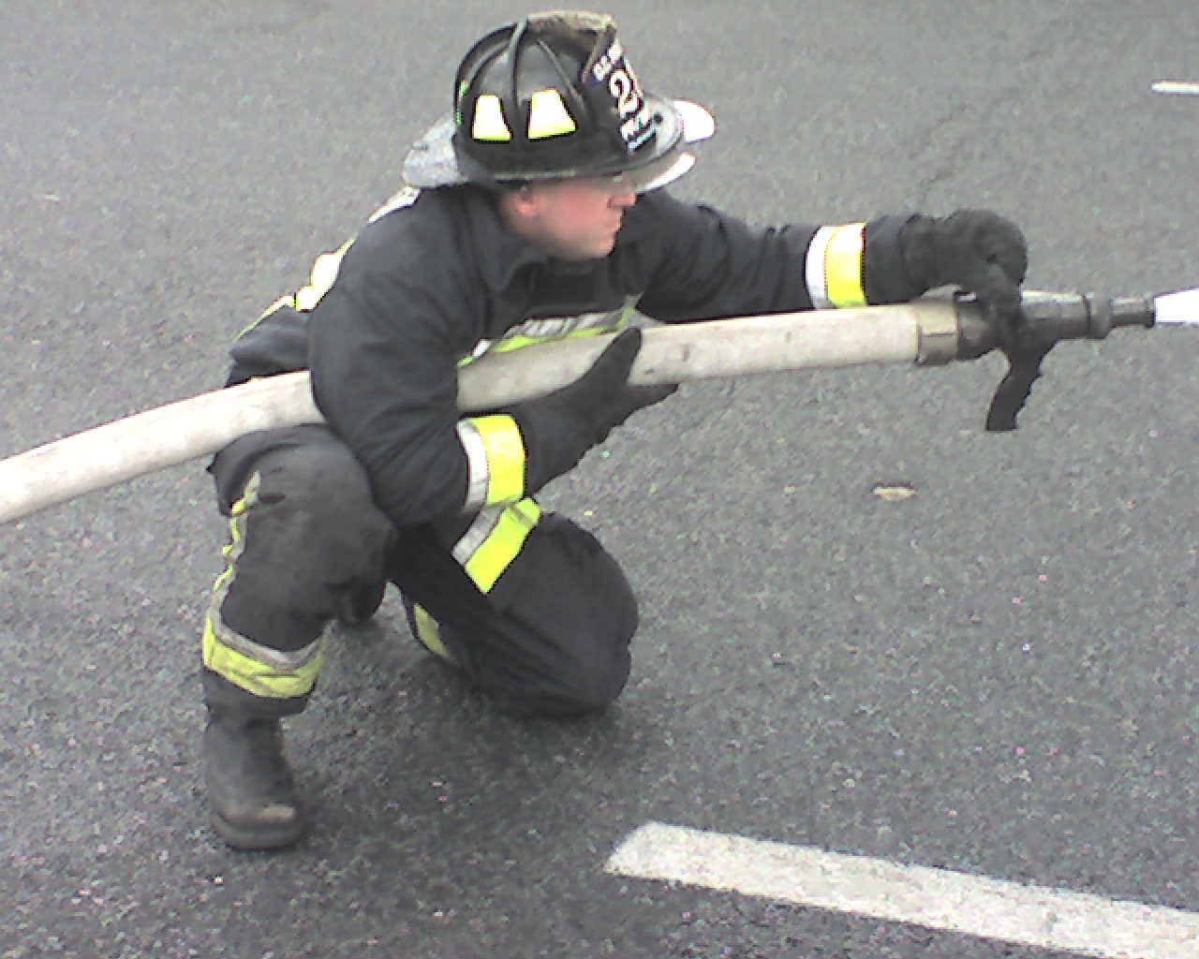

  - Two firefighters/back-to-back

This can be done with airpacks on.
The backup person should be doing the bulk
of the work; notice how the backup person
is using their legs and their body weight to
help control the line. This makes the work
much easier.

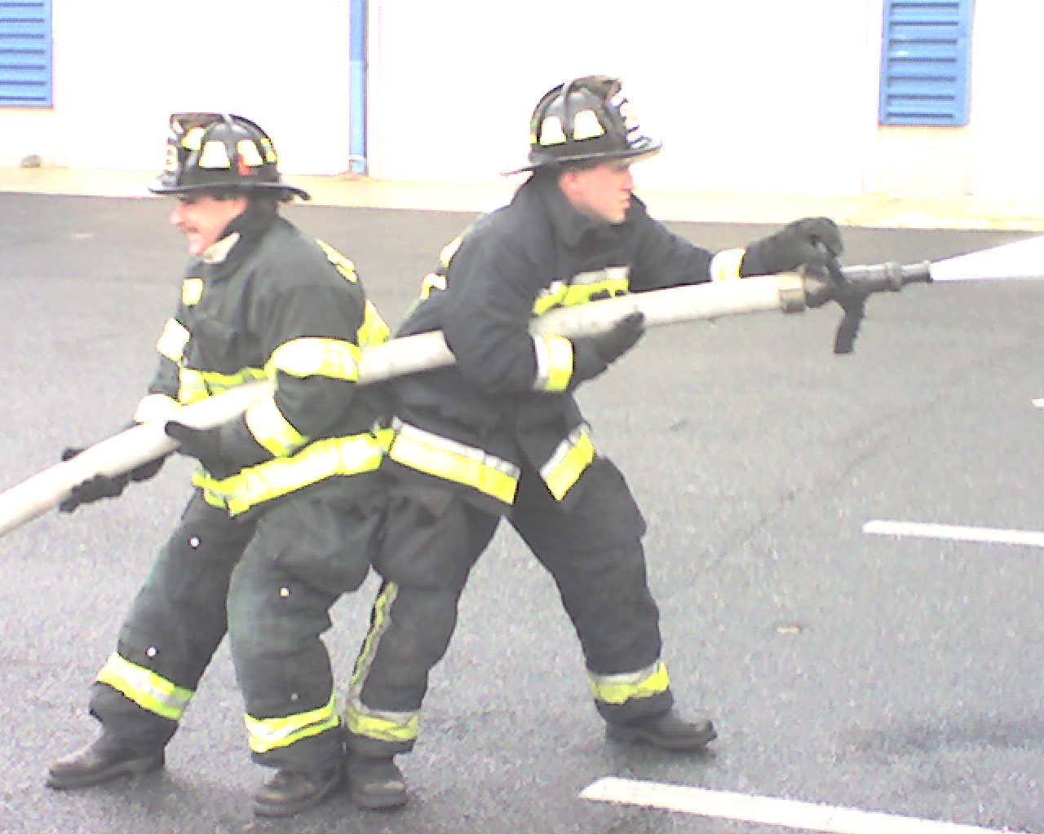

III: Have all participants demonstrate above techniques

Ensure that back-up personnel are in position and prepared to intervene/provide assistance

REVIEW:

Student Performance Objective:
Given information from lecture and demonstration the student will be able to recognize situations where it is appropriate to utilize a 2 ½ inch attack line and demonstrate the different methods for the deployment and use of this line to the satisfaction of the instructor.

- When use of a 2 ½ inch attack is needed
- Techniques for utilizing the 2 ½ inch attack line

ASSIGNMENT:

=================================================================

EVALUATION:

